Full Stack Development with MERN Project Documentation format

Introduction
  - Project Title: UCab – MERN Stack Cab Booking Management System
  - Team Members:
Name | Role
Bharadwaj Annepu (Team Lead) | Project Planning, Database Design, Frontend-Backend Integration & Final Testing
Sailaja Kaisarla | Testing Engineer, Presentation & Documentation
Praveen Thiruveedi | Frontend Developer
Venkata Vijay Kumar Valiveti | Backend Developer, API’s Modelling

Project Overview
- Purpose:
UCab is a web-based cab booking application developed using the MERN Stack. The system allows users to register, log in, search for available cabs, book rides, and manage their bookings. Administrators can manage cab details and monitor bookings through an admin dashboard. The main objective is to simplify the cab booking process by providing a secure and user-friendly platform.
  - Features:
The UCab Cab Booking Management System is designed to provide a seamless and efficient platform for both users and administrators. It offers essential functionalities such as secure user authentication, cab booking, booking management, and administrative controls for managing cabs and ride availability. The following table summarizes the key features of the application along with their respective functionalities.

Feature | Functionality
User Registration | Allows new users to create an account by providing personal details such as name, email, and password. User information is securely stored in the MongoDB database after validation.
User Login | Enables registered users to log in using their email and password. The system verifies credentials and grants access to authorized once
JWT Authentication | Implements secure authentication using JSON Web Tokens (JWT). After successful login, a token is generated and used to authorize access to protected routes and APIs.
View Available Cabs | Displays a list of available cabs with details such as cab name, cab number, seating capacity, fare, and availability status. Users can browse and select a suitable cab.
Book a Cab  Booking Confirmation | Allows users to book an available cab by selecting the desired vehicle and entering the required booking information. The booking details are stored in the database.
 | After a successful booking, the system displays a confirmation message containing the booking details, ensuring that the ride has been reserved successfully.
View Booking History  Cancel Booking | Enables users to view all their previous and current bookings, including booking date, cab details, fare, and booking status.  Allows users to cancel an existing booking before the scheduled ride. The booking status is updated, and the selected cab becomes available again.
Admin Login | Provides a secure login portal for administrators to access the admin dashboard and perform management operations.
Add New Cab | Enables administrators to add new cab information, including cab name, registration number, seating capacity, fare, and availability status.
Update Cab Details | Allows administrators to modify existing cab information such as fare, availability, seating capacity, or other details whenever necessary.
Delete Cab | Provides administrators with the option to permanently remove a cab from the system when it is no longer in service.
Manage Cab Availability | Enables administrators to update the availability status of cabs based on bookings or maintenance, ensuring users only view available vehicles.
Responsive User Interface | The application is designed with a responsive layout that adapts to desktops, tablets, and mobile devices, providing a consistent and user-friendly experience across different screen sizes.

Architecture
The UCab Cab Booking Management System follows the MERN (MongoDB, Express.js, React.js, and Node.js) architecture, which provides a scalable, modular, and efficient framework for developing full-stack web applications. The frontend and backend communicate through RESTful APIs, while MongoDB serves as the database for storing application data.
  - Frontend:
The frontend is built using React.js, providing a responsive and interactive user interface through reusable components. It follows a component-based architecture for better maintainability and code reusability. React Router enables smooth navigation between pages, while Axios handles communication with backend APIs for real-time data exchange. The responsive design ensures a consistent experience across desktop, tablet, and mobile devices.
Frontend Components
- User Registration and Login Pages
- Home Dashboard
- Cab Listing Page
- Cab Booking Form
- Booking History Page
- Admin Dashboard
- Cab Management Pages
- Navigation Bar and Footer
- Protected Routes for Authorized Users

  - Backend:
The backend is developed using Node.js and Express.js, handling business logic, API requests, authentication, and database operations. It follows a modular architecture with separate routes, controllers, models, and middleware for better scalability and maintainability. RESTful APIs enable frontend interactions, while JWT-based authentication ensures secure access to protected resources.

Backend Modules
- Authentication Module
- User Management
- Cab Management
- Booking Management
- JWT Authentication Middleware
- Error Handling Middleware
- REST API Services
  - Database:
The application uses MongoDB, a NoSQL database, to efficiently store and manage data. Mongoose serves as the ODM layer, simplifying schema design, validation, and database operations. Through Mongoose models, the system performs CRUD operations for managing users, cabs, and bookings.

a) Database Collections:

1) Users Collection
Stores user information required for authentication and authorization.
Field | Data Type | Description
_id | ObjectId | Unique User ID
name | String | User Name
email | String | User Email
password | String | Encrypted Password
role | String | User/Admin Role
Field | Data Type | Description
_id | ObjectId | Unique Cab ID
cabName | String | Cab Name
cabNumber | String | Registration Number
seats | Number | Seating Capacity
price | Number | Fare per Ride
available | Boolean | Cab Availability Status

2) Cabs Collection
Stores information about all available cabs.

3) Bookings Collection

Stores booking details created by users.
Field | Data Type | Description
_id | ObjectId | Booking ID
userId | ObjectId | Reference to User
cabId | ObjectId | Reference to Cab
bookingDate | Date | Date of Booking
amount | Number | Booking Fare
status | String | Booking Status

b) Database Interactions

The backend communicates with MongoDB through Mongoose to perform the following operations:

Register and authenticate users.

Store and retrieve user information.

Add, update, delete, and view cab details.

Create new cab bookings.

Retrieve users' booking history.

Cancel bookings and update cab availability.

Manage administrative operations securely.

Setup Instructions
  - Prerequisites:
Install the following software:
- Node.js
- npm
- MongoDB
- Git
- VS Code
  - Installation:
Follow the steps below to set up and run the UCab application on your local system.
1. Clone the Repository
Clone the project repository from GitHub:
git clone https://github.com/User-Bharadwaj/Ucab
2. Navigate to the Project Directory
Move into the project folder:
cd UCab
3. Install Frontend Dependencies
Navigate to the frontend directory and install the required packages:
cd client
npm install
4. Install Backend Dependencies
Navigate to the backend directory and install the required packages:
cd ../server
npm install
5. Configure Environment Variables
Create a .env file inside the server directory and add the following configuration values:
PORT=5000
MONGO_URI=your_mongodb_connection_string
JWT_SECRET=your_secret_key
Environment Variables Description
Variable | Description
PORT | Port number on which the backend server will run
MONGO_URI | MongoDB database connection string
JWT_SECRET | Secret key used for JWT authentication and authorization

6. Start the Application
- Start Backend Server
cd server
npm start
- Start Frontend Application
Open a new terminal and run:
cd client
npm start

7. Access the Application
After both servers are running successfully, open your browser and navigate to:http://localhost:5173
The UCab application should now be accessible and ready for use.

Folder Structure
  - Client (React Frontend)
The frontend of the UCab application is developed using React.js and follows a modular structure to improve code organization, maintainability, and scalability.
client/
│
├── public/
│
├── src/
│ │
│ ├── components/
│ │ ├── Home.jsx
│ │ ├── Login.jsx
│ │ ├── Register.jsx
│ │ ├── Uhome.jsx
│ │ ├── Cabs.jsx
│ │ ├── BookCab.jsx
│ │ ├── MyBookings.jsx
│ │ ├── Profile.jsx
│ │ ├── Unav.jsx
│ │ └── ProtectedRoute.jsx
│ │
│ ├── admin/
│ │ ├── Alogin.jsx
│ │ ├── Ahome.jsx
│ │ ├── Anav.jsx
│ │ ├── Acabs.jsx
│ │ ├── Addcar.jsx
│ │ ├── AcabEdit.jsx
│ │ ├── Users.jsx
│ │ └── Bookings.jsx
│ │
│ ├── App.jsx
│ ├── main.jsx
│ └── styles/
│
├── services/
│ └── api.js
│
└── package.json
Directory Description

- client/: The root directory of the React frontend application. It contains all source code, public assets, and project configuration files.
- src/: The main source folder that contains all React application code, including components, pages, services, and entry files.
- src/components/: Contains reusable UI components used throughout the application, such as navigation bars, forms, buttons, cards, modals, and other common interface elements.
- src/pages/: Contains page-level components representing different application screens, such as Login, Registration, Home, Booking, Profile, and Admin Dashboard pages.
- src/services/: Contains service files responsible for communicating with backend APIs. Axios requests, authentication services, booking services, and cab management services are typically implemented here.
- src/App.js: The main application component that defines routing, layouts, and the overall structure of the React application.
- src/index.js: The entry point of the React application. It renders the root component and initializes the application in the browser.
- public/: Contains static assets such as the HTML template, images, icons, and other files that are served directly to the browser without processing by React.
- package.json: Contains project metadata, dependencies, scripts, and configuration required to build and run the React application.

- Server (Backend)
The backend of the UCab application is developed using Node.js and Express.js. It follows a modular architecture that separates business logic, database models, routes, middleware, and configuration files, making the application scalable and easier to maintain.

server/
│
├── controllers/
│ ├── userController.js
│ ├── adminController.js
│ ├── carController.js
│ └── bookingController.js
│
├── models/
│ ├── User.js
│ ├── Admin.js
│ ├── Car.js
│ ├── Booking.js
│ └── Payment.js
│
├── routes/
│ ├── userRoutes.js
│ ├── adminRoutes.js
│ ├── carRoutes.js
│ └── bookingRoutes.js
│
├── middlewares/
│ └── authMiddleware.js
│
├── db/
│ └── config.js
│
├── seed.js
├── server.js
├── .env
└── package.json
Directory Description
- server/: The root directory of the backend application. It contains all server-side code, configurations, and dependencies required to run the application.
- controllers/: Contains controller files that handle business logic and process incoming API requests. Controllers interact with models, perform operations, and return responses to the client.
- models/: Contains Mongoose models and database schemas that define the structure of data stored in MongoDB, such as Users, Cabs, and Bookings.
- routes/: Contains API route definitions. Routes map HTTP requests (GET, POST, PUT, DELETE) to the appropriate controller functions for processing.
- middleware/: Contains custom middleware functions used for request processing, authentication, authorization, error handling, and validation.
- config/: Contains configuration files for database connections, environment settings, and other application-level configurations.
- server.js: The main entry point of the backend application. It initializes the Express server, configures middleware, establishes database connections, and registers API routes.
- package.json: Contains project metadata, dependencies, scripts, and configuration required to run and manage the backend application.

Running the Application

Before running the application, ensure that all required dependencies are installed and that MongoDB is running. The frontend and backend servers should be started separately in their respective directories.
- Backend Server
- Open a terminal and navigate to the server directory.
cd server
- Install the required dependencies (if not already installed).
npm install
- Start the backend server.
npm start
The backend server will run on:
http://localhost:5000

- Frontend Server
- Open a new terminal and navigate to the client directory.
cd client
- Install the required dependencies (if not already installed).
npm install
- Start the React development server.
npm start
The frontend application will run on: http://localhost:5173
- Running Both Servers
To use the application successfully:
- Ensure that MongoDB is running.
- Start the backend server from the server directory.
- Start the frontend server from the client directory.
- Open your web browser and navigate to:http://localhost:5173
The React frontend communicates with the Express.js backend through RESTful APIs, while the backend interacts with the MongoDB database to process user requests, manage cab information, and handle booking operations.

Expected Application Flow:
Start MongoDB
│
▼
Start Backend (Server)
npm start
│
▼
Start Frontend (Client)
npm start
│
▼
Open Browser
http://localhost:3000
│
▼
Use the UCab Cab Booking Management System

API Documentation
The backend of the UCab Cab Booking Management System provides a set of RESTful APIs to facilitate communication between the React frontend and the MongoDB database. These APIs handle user authentication, cab management, and booking operations. The following tables describe the available endpoints, request methods, required parameters, and sample responses.

- Authentication APIs
Endpoint | /api/auth/register
Method | POST
Description | Registers a new user.
  - Register User

Request Body
{
"name": "Rahul Sharma",
"email": "rahul@example.com",
"password": "password123"
}

Success Response
{
"message": "User registered successfully."
}

2. Login User
Endpoint | /api/auth/login
Method | POST
Description | Authenticates a user and returns a JWT token.

Request Body
{
"email": "rahul@example.com",
"password": "password123"
}

Success Response
{
"token": "eyJhbGciOiJIUzI1NiIsInR5cCI6IkpXVCJ9...",
"user": {
"name": "Rahul Sharma",
"role": "user"
}
}

- Cab APIs
3. Get All Available Cabs
Endpoint | /api/cabs
Method | GET
Description | Retrieves the list of all available cabs.

Success Response
[
{
"_id": "101",
"cabName": "Swift Dzire",
"cabNumber": "AP16AB1234",
"price": 500,
"seats": 4,
"available": true
}
]

4. Add New Cab (Admin)
Endpoint | /api/cabs
Method | POST
Description | Adds a new cab to the system.

Request Body
{
"cabName": "Toyota Innova",
"cabNumber": "AP16CD5678",
"price": 900,
"seats": 7,
"available": true
}

Success Response
{
"message": "Cab added successfully."
}

5. Update Cab Details
Endpoint | /api/cabs/:id
Method | PUT
Description | Updates an existing cab's information.
Request Body
{
"price": 1000,
"available": false
}

Success Response
{
"message": "Cab updated successfully."
}

6. Delete Cab
Endpoint | /api/cabs/:id
Method | DELETE
Description | Deletes a cab from the database.
Success Response
{
"message": "Cab deleted successfully."
}

- Booking APIs
7. Book a Cab
Endpoint | /api/bookings
Method | POST
Description | Creates a new booking for the selected cab.
Request Body
{
"userId": "1001",
"cabId": "2001",
"bookingDate": "2026-07-12",
"amount": 750
}

Success Response
{
"message": "Booking successful.",
"bookingId": "BK12345"
}

8. View Booking History
Endpoint | /api/bookings
Method | GET
Description | Retrieves all bookings for the logged-in user.
Success Response
[
{
"bookingId": "BK12345",
"cabName": "Swift Dzire",
"bookingDate": "2026-07-12",
"amount": 750,
"status": "Confirmed"
}
]

9. Cancel Booking
Endpoint | /api/bookings/:id
Method | DELETE
Description | Cancels an existing booking.
Success Response
{
"message": "Booking cancelled successfully."
}

Authentication
The UCab Cab Booking Management System uses JSON Web Tokens (JWT) for secure authentication and authorization. Authentication verifies the identity of users during login, while authorization ensures that users can only access features based on their assigned roles.
- Authentication Process
- Users register by providing their name, email, and password.
- Passwords are securely encrypted before being stored in the MongoDB database.
- During login, the backend validates the user's credentials.
- Upon successful authentication, a JWT token containing the user's ID and role is generated.
- The token is stored on the client side and included in the Authorization header for all protected API requests.
- The backend verifies the token before granting access to secured resources.
- Authorization
The application follows role-based authorization:
- User: Can view available cabs, book rides, view booking history, and cancel bookings.
- Admin: Can add, update, delete, and manage cab details and availability, as well as oversee booking information.

Only users with the appropriate role are allowed to access protected routes and perform administrative operations.
- Token Management
JWT is used to securely manage user sessions without maintaining server-side session data. Each authenticated request includes the token, which is validated by the backend to ensure secure access. Invalid or expired tokens are rejected, preventing unauthorized access.
- Authentication Workflow
User Registration
│
▼
User Login
│
▼
Credential Verification
│
▼
JWT Token Generated
│
▼
Token Stored on Client
│
▼
Token Sent with API Requests
│
▼
Backend Verifies Token
│
▼
Access Granted or Denied

User Interface

The application includes the following interfaces:

User Registration & Login
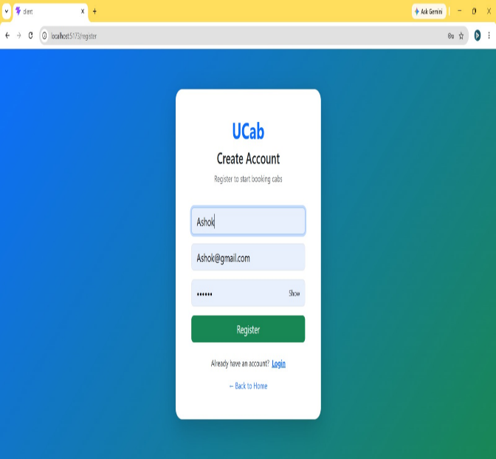
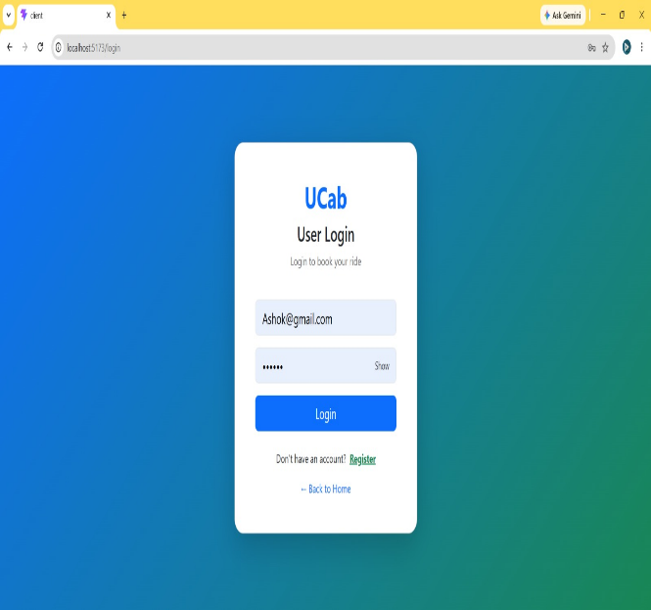

- Admin Login
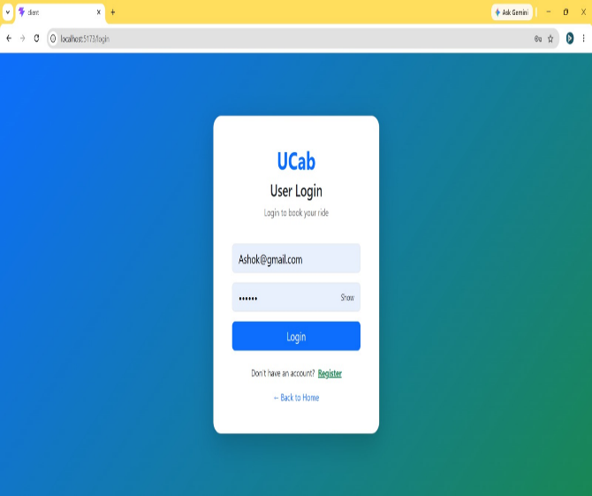
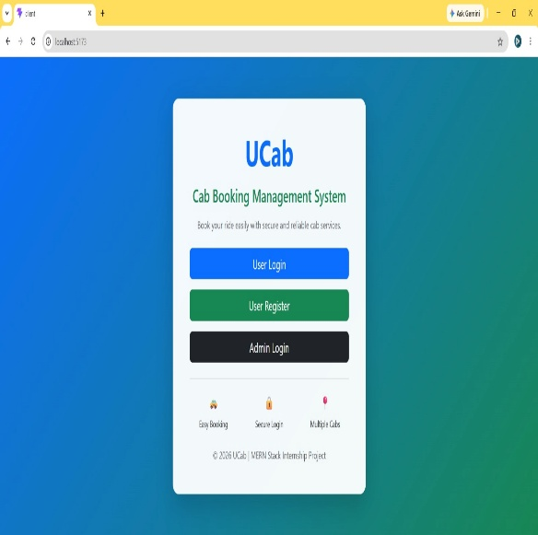

- Home Dashboard
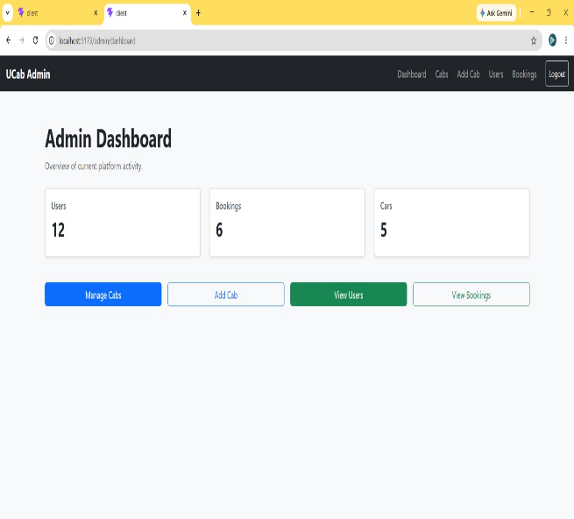
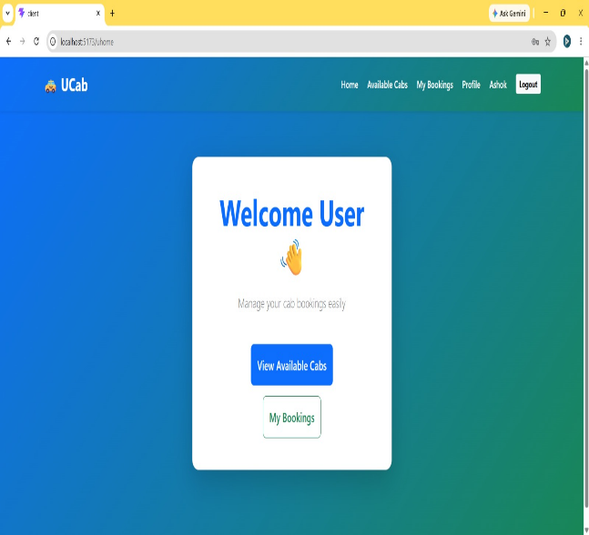

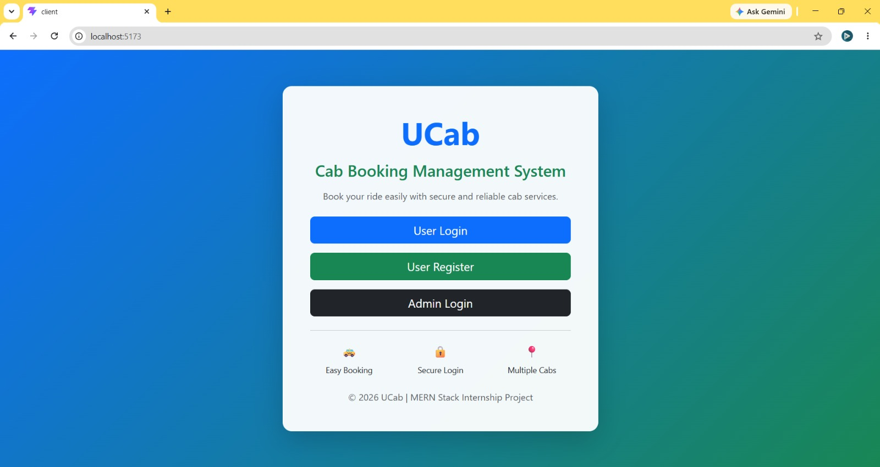

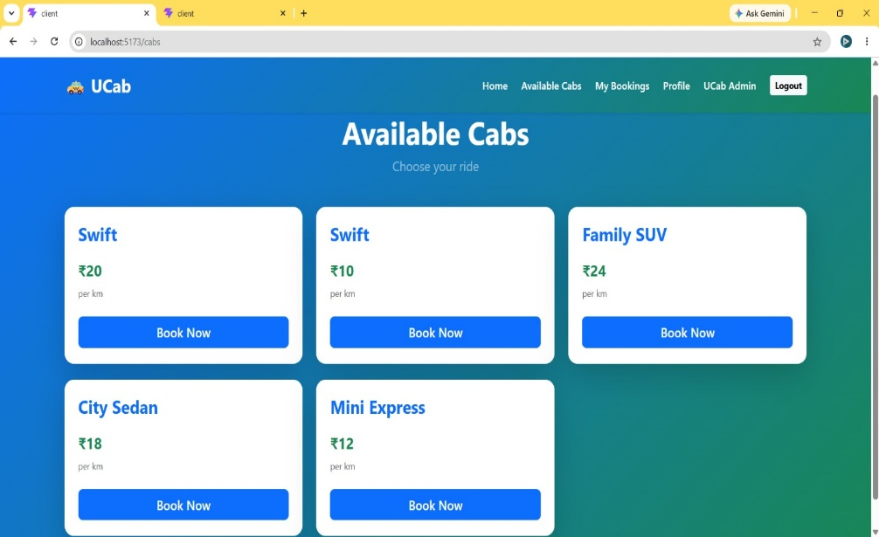
d) Browse Available Cabs

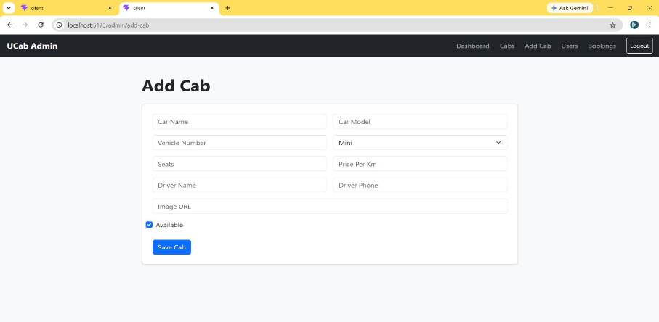
- Add Cab

- Book Cab
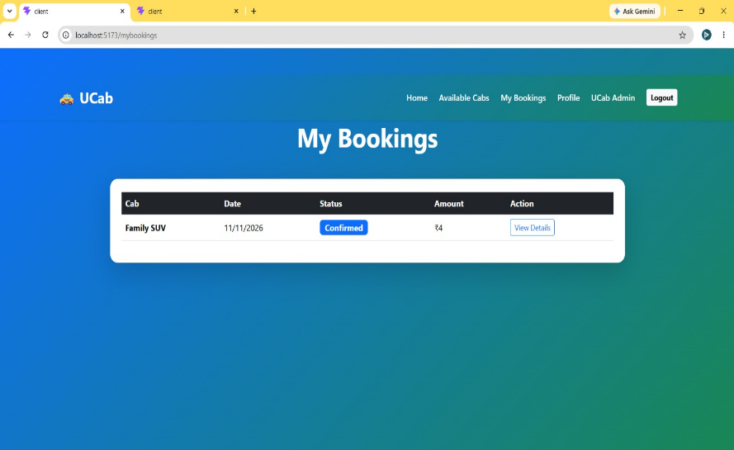

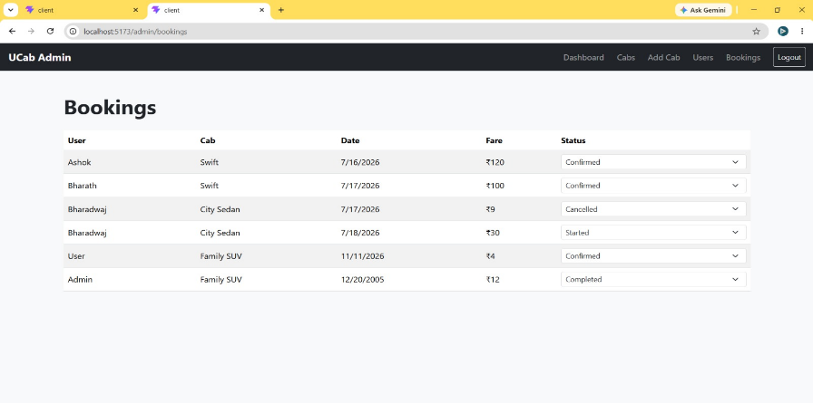
- Booking History

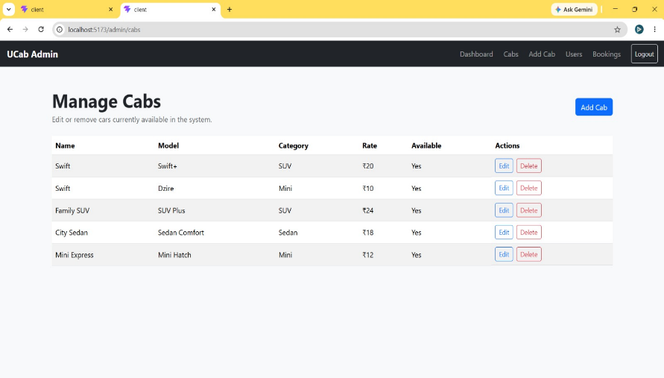
- Fare Calculation & Cabs Management

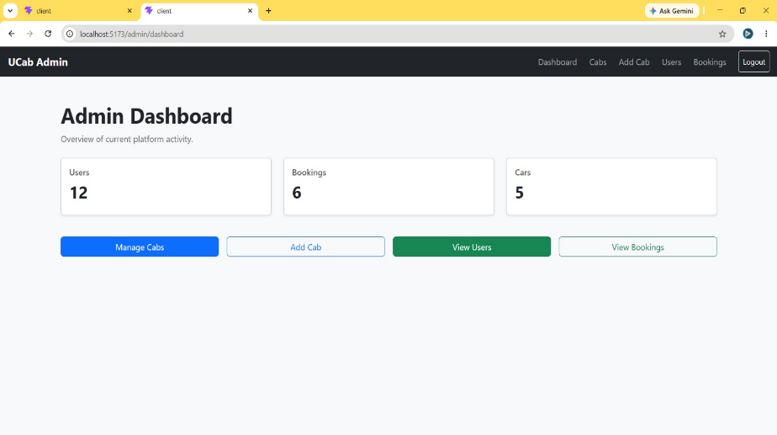
- Admin Dashboard

Testing
The UCab Cab Booking Management System was tested to ensure that all functionalities work correctly and provide a reliable user experience. Both frontend and backend components were tested individually and together to verify seamless communication between the client, server, and database.
a) Testing Strategy

Verified user registration and login functionality.

Tested JWT-based authentication and role-based authorization.

Validated cab booking, booking history, and booking cancellation features.

Performed CRUD operations for cab management (Add, Update, Delete, and View).

Tested RESTful API endpoints and database interactions.

Conducted UI testing to ensure responsive design and smooth navigation across different pages.
- Testing Tools
    - Postman – Used for testing REST API endpoints and verifying request/response data.
    - MongoDB Compass – Used to inspect and validate data stored in the MongoDB database.
    - Google Chrome Developer Tools – Used for debugging frontend components and monitoring API requests.
    - React Development Server (npm start) – Used for testing the frontend during development.
    - Node.js & Express Server – Used to test backend functionality and API execution.

Screenshots or Demo
Demo Video:
GitHub -
Drive link -
For Screenshots:
https://drive.google.com/drive/folders/1WgI_ur7ZCLhEggCVovMH4czoLJxLwQ7T?usp=sharing
For Video:
https://drive.google.com/file/d/1SLteE50a6HgMTIFhAqgtR6nRMgRjcH0J/view?usp=sharing

Known Issues
The current version of the UCab Cab Booking Management System is fully functional; however, a few limitations and areas for improvement remain:

The application does not support online payment integration for cab bookings.

Real-time cab tracking using GPS or maps is not implemented.

Booking confirmation notifications via email or SMS are not available.

The system currently supports basic authentication and can be enhanced with features such as password recovery and multi-factor authentication.

Performance may decrease when handling a very large number of concurrent users without additional optimization.

These limitations do not affect the core functionality of the application and can be addressed in future versions to enhance the overall user experience.

These limitations do not affect the core functionality of the application and can be addressed in future versions to enhance the overall user experience.

Future Enhancements

The UCab Cab Booking Management System can be further enhanced by incorporating advanced features to improve functionality, user experience, and scalability. Some potential future enhancements include:

Online Payment Integration: Integrate secure payment gateways such as Razor pay or Stripe for seamless online transactions.

Real-Time Cab Tracking: Implement GPS and Google Maps integration to enable users to track their booked cabs in real time.

Ride Ratings and Reviews: Allow users to rate drivers and provide feedback after completing a ride.

Email and SMS Notifications: Send booking confirmations, ride updates, and cancellation notifications via email or SMS.

Driver Management Module: Add a dedicated module for driver registration, profile management, and ride assignments.

Advanced Search and Filters: Enable users to search and filter cabs based on fare, seating capacity, availability, and vehicle type.

Mobile Application: Develop Android and iOS applications using React Native to provide a better mobile experience.

Analytics Dashboard: Introduce dashboards with reports and insights for administrators to monitor bookings, revenue, and user activity.

These enhancements would improve the overall usability, security, and efficiency of the application while making it more suitable for real-world deployment.

Conclusion
UCab successfully implements a complete MERN Stack Cab Booking System with secure authentication, cab management, booking management, and administrative control. The project demonstrates practical full-stack development skills and provides a scalable foundation for future enhancements in transportation and ride-booking services.

